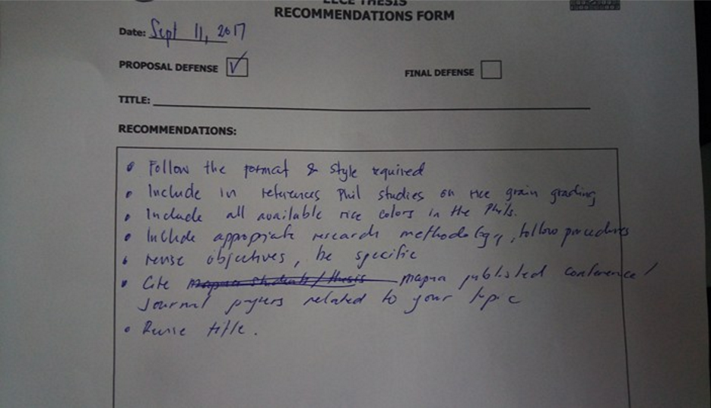Alcala, N. L. D., Dela, L. J. C., Lazaro, T. P. F. and Llanto, J. M (2014). MATLAB Toolbox Creation for Rice Kernel Segmentation and Characterization Including Touching Kernels Separation by Edge Reconstruction Method. *Mapua University.*

Belsnio, B. (1988). The anatomy and physical properties of the rice grain. *Towards Integrated Commodity and Pest Management in Grain Storage. FAO, Rome*

Concepcion J. C. T., Ouk M., Zhao D., and Fitzgerald M. A. (2015). The need for new tools and investment to improve the accuracy of selecting for grain quality in rice. *Field Crops Research*. Volume 182, Pages 60-67.

De Jesus, M. L. B., Mayores, A. J. C., and Recuelo, M. A., (2016). Measurement of Grain Shape, Whiteness, Chalkiness and Moisture Content of Dinorado and Sinandomeng Rice Samples using a Raspberry-Pi Based Portable Rice Grain Sampler. *Mapua University.*

Guzman, J. D., & Peralta, E. K. (2008). Classification of Philippine rice grains using machine vision and artificial neural networks. *World conference on agricultural information and IT*, Tokyo, Japan (pp. 24-27).

Juliano B. O., (2016). Rice: Overview, *Encyclopedia of Food Grains (Second Edition)*. Academic Press, Oxford, pp. 125-129.

O. C. Agustin and B. J. Oh, (2008). Automatic Milled Rice Quality Analysis. *2008 Second International Conference on Future Generation Communication and Networking*, Hainan Island, pp. 112-115.